**Name : Shruti Sharad Throat**

**Email id:shruti96thorat@gmail.com**

**Power bi Task:-01**

**Dataset:- Exhaustive Analysis of Indian Agriculture.csv**

**Step1:Load dataset**

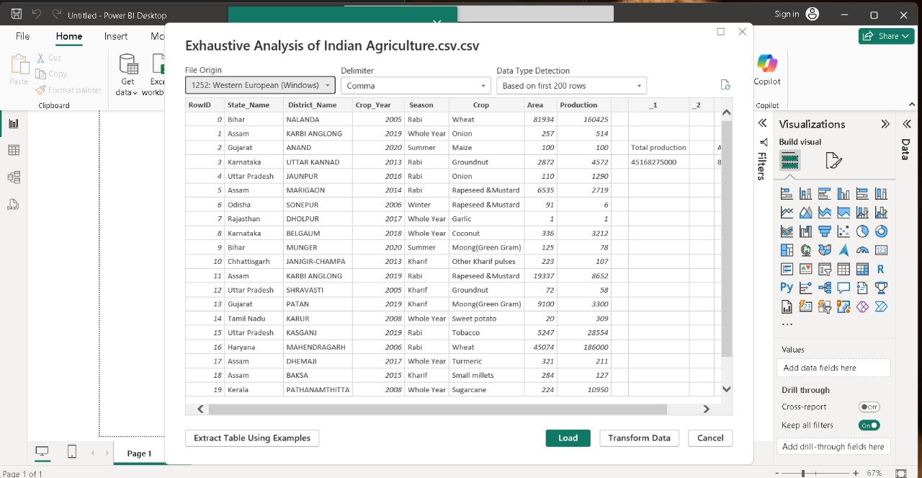

**Step 2: Types of model**

1. **Table view**

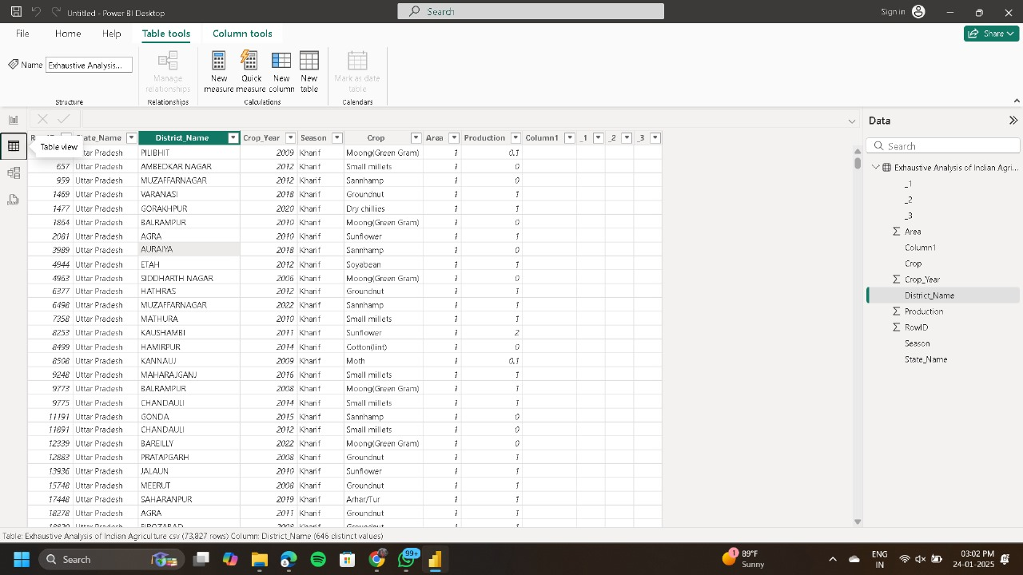

1. **Model view**

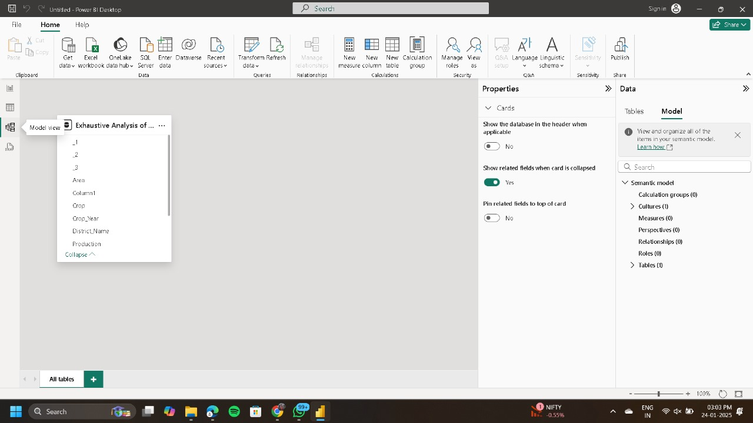

**Step 3: Transform the dataset:**

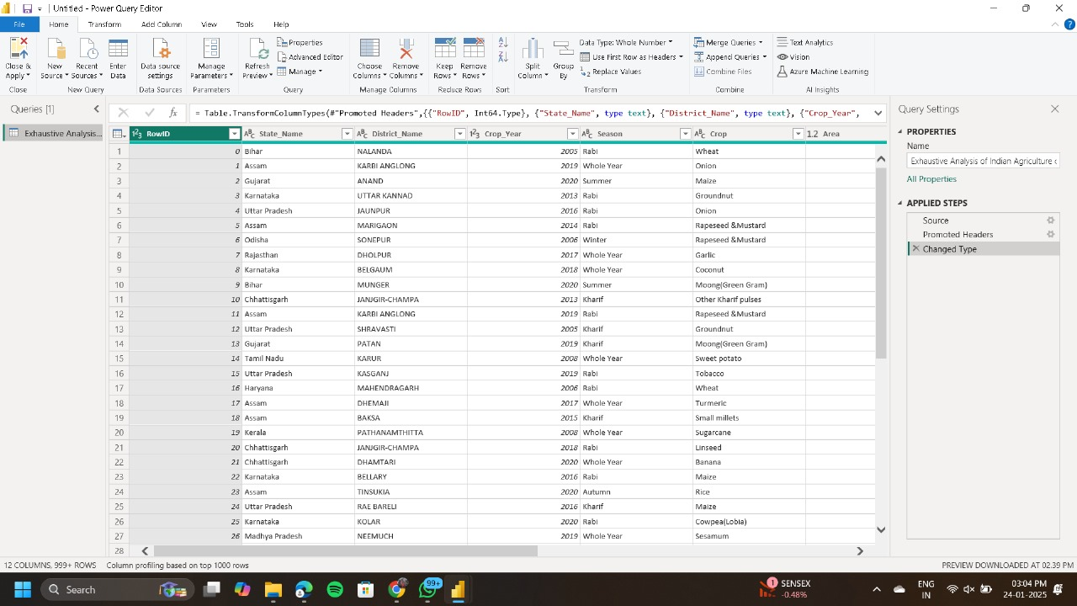

**Step 4:Column remove :**

1. **Roll no column**

* **Before remove**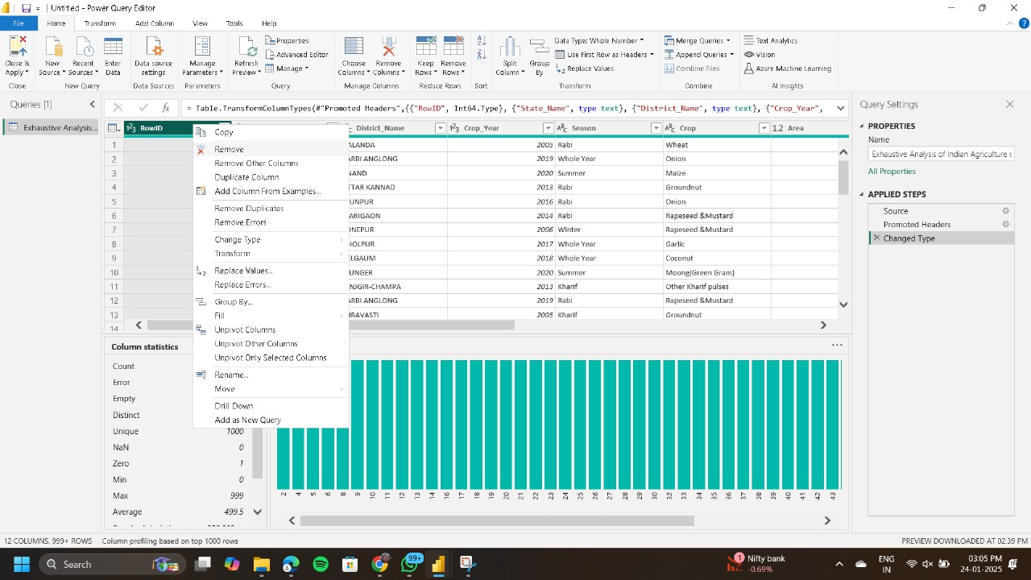
* **After remove**

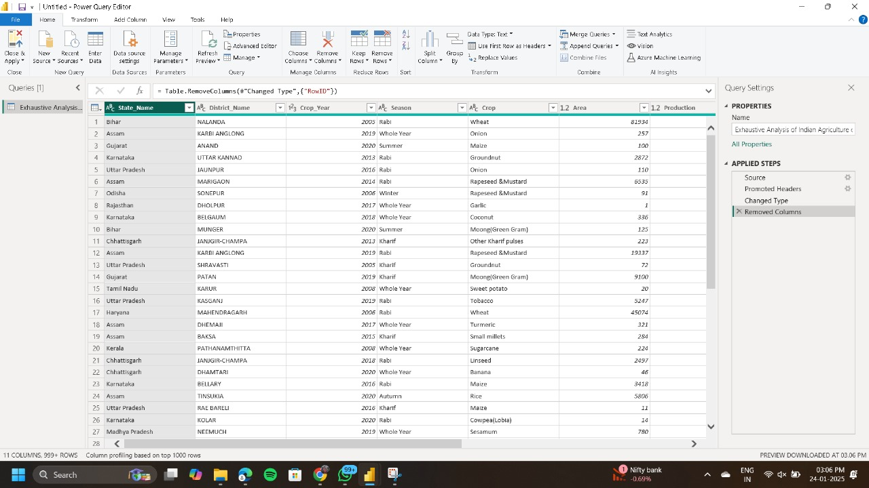

1. **Empty column:**

* **Before remove**

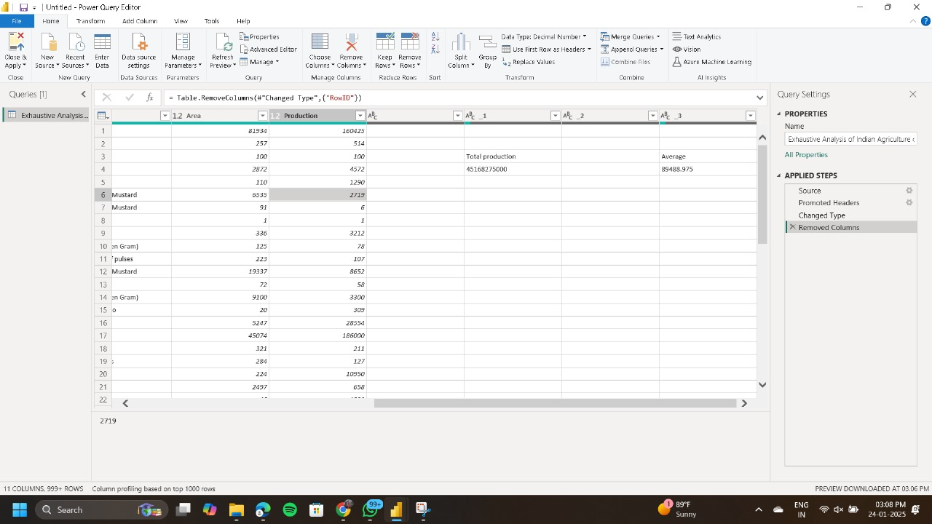

* **After remove**

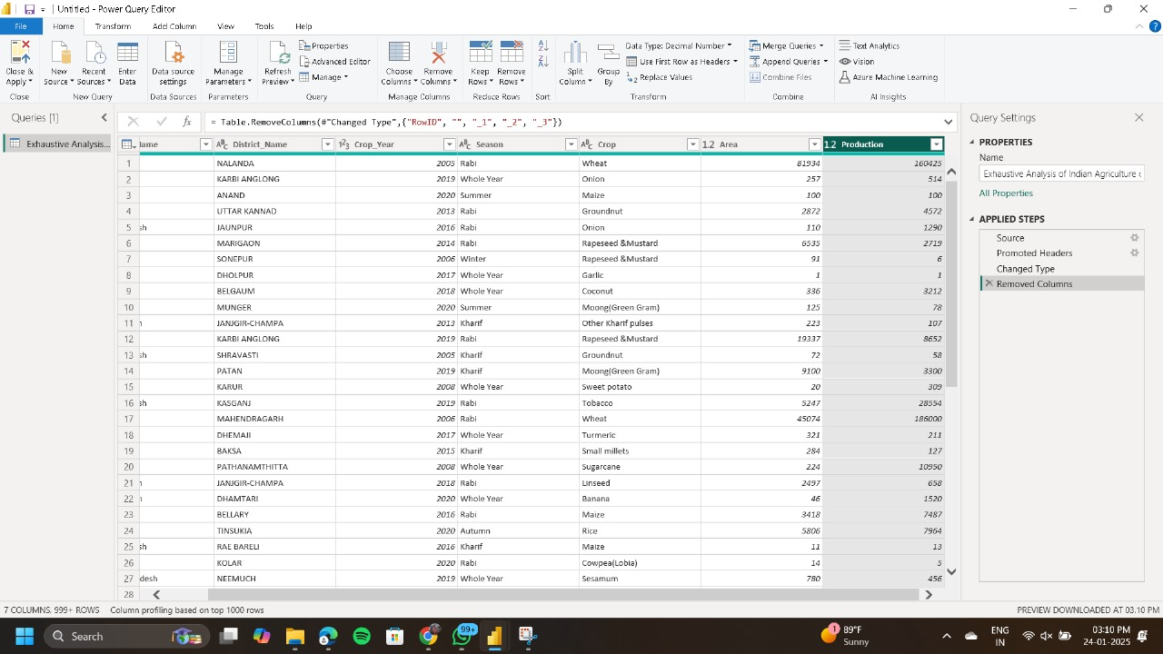

**Step 5:column quality:**

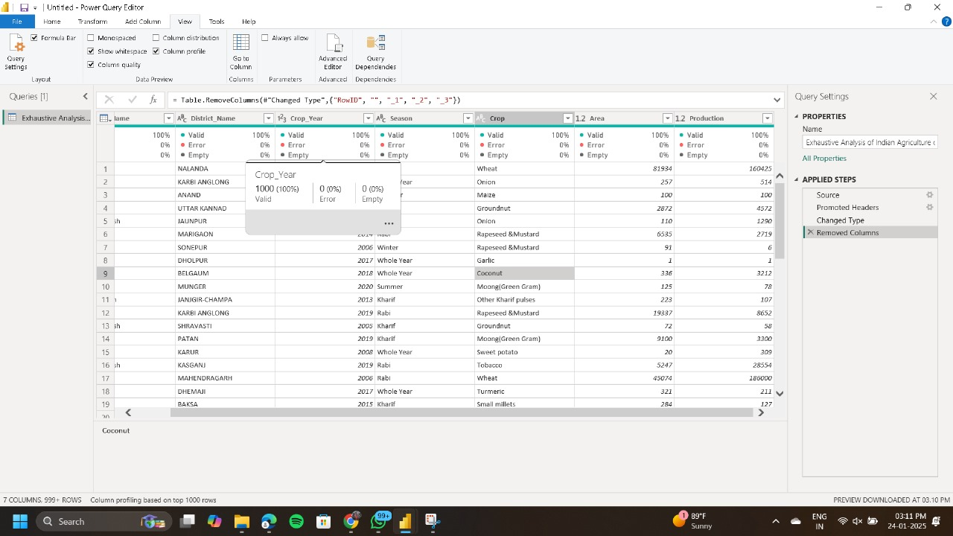

**Step 6: Remove blank row**

* **Before row removing**

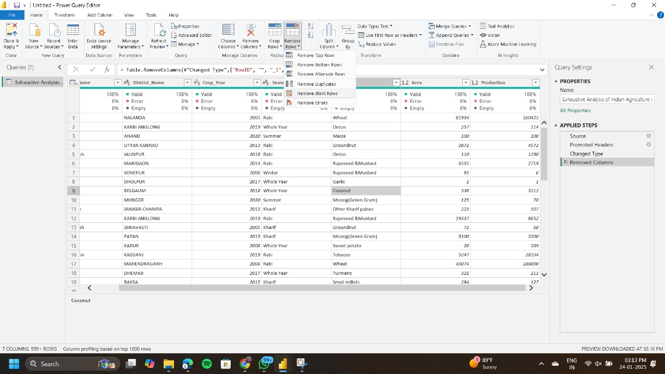

* **After row removing**

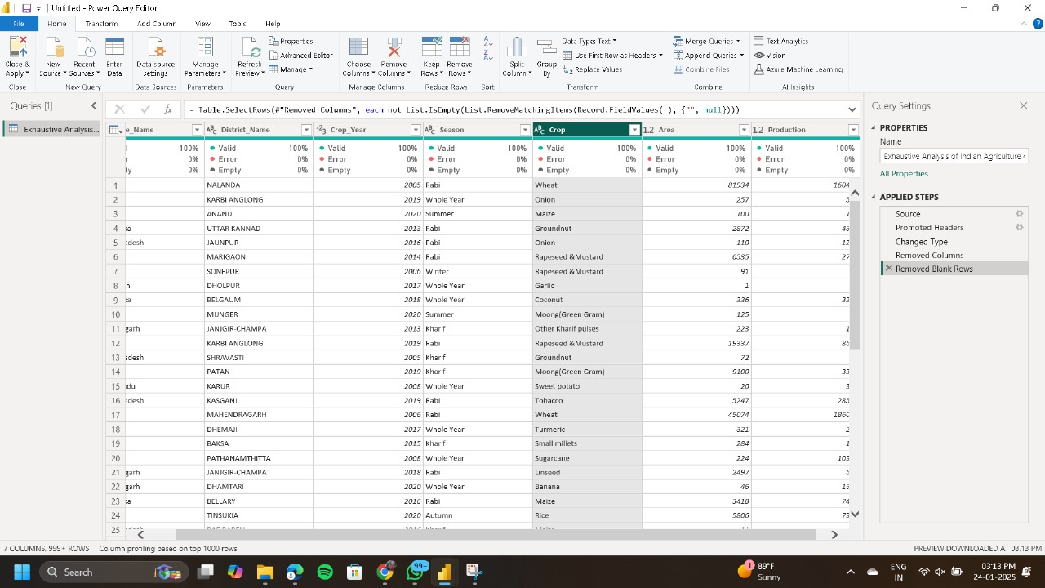

**Step 7: Remove duplicate row:-**

* **Before duplicate row:-**

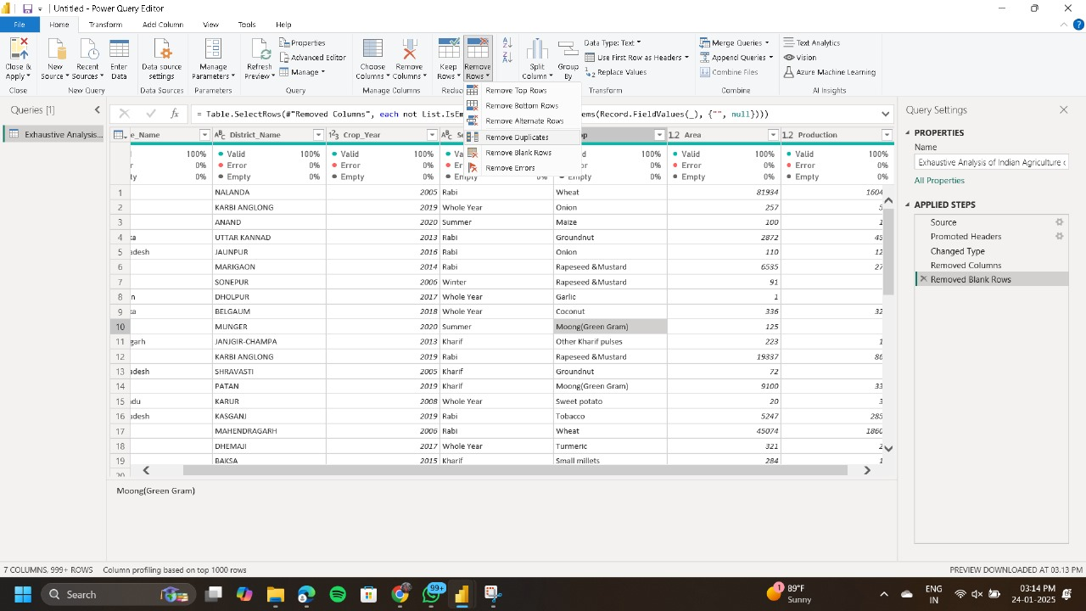

* **After duplicate row:-**

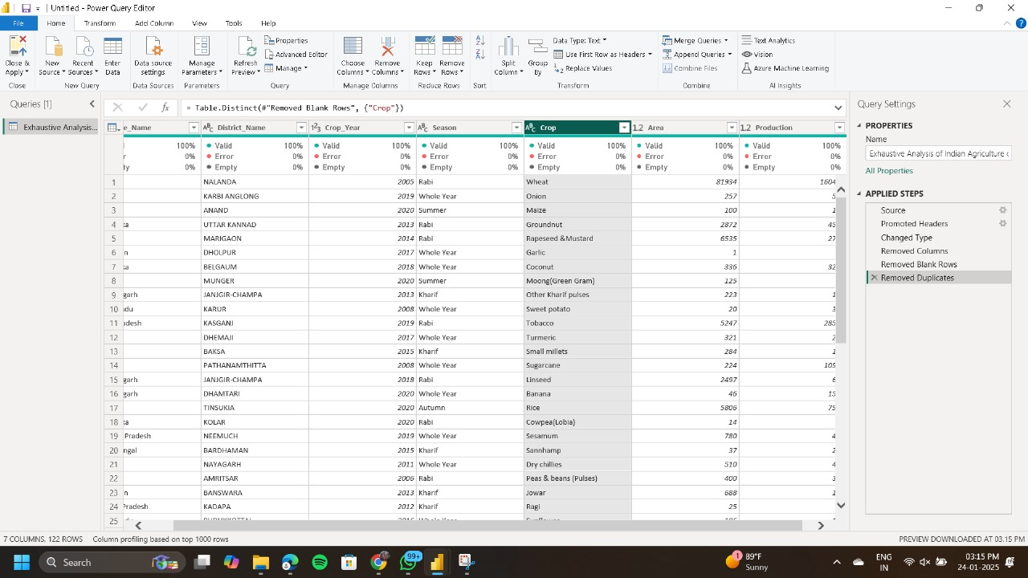

**Step 8:close and apply:-**

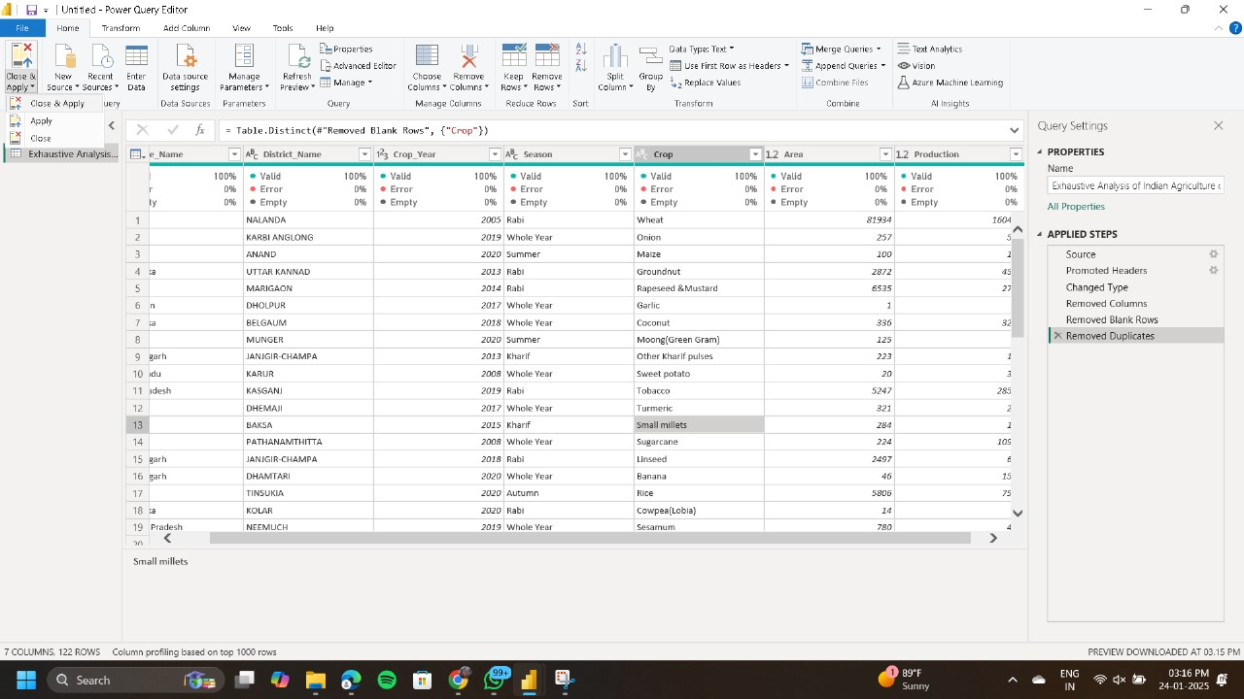

**Step 9:final table after clean up:-**

